NHD Georgia State Contest T-Shirt Order Form

Please complete this order form and return by mail with payment to:

NHD Georgia, History Department
Attn: Sonya Hill White
LaGrange College
601 Broad Street
LaGrange, Georgia 30240

All order forms and payments must be received by April 3. Only checks or money orders payable to LaGrange College please.

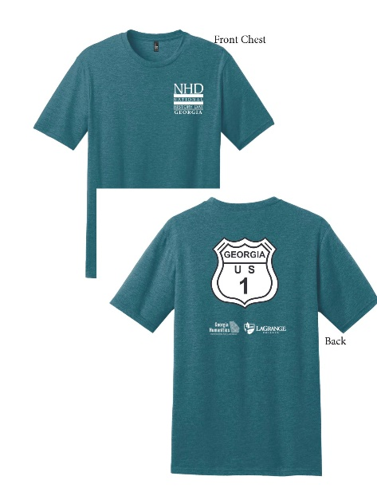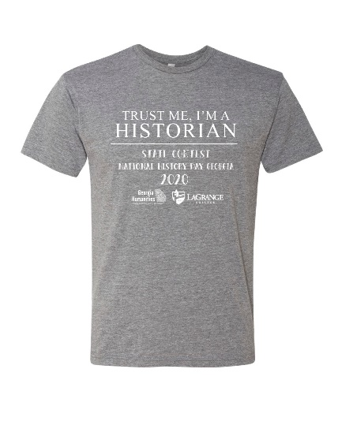
The “road sign” shirt will be a heathered turquoise shirt with white lettering and print on the front and back. The “Trust Me” shirt will be a heathered gray shirt with white lettering. It is printed only on the front. These shirts will be available for pick up at the contest.

Cost: “Trust Me” - $12.00 “Road Sign” - $15.00 per shirt. (Please add $2 for XXL, $3 FOR XXXL)

Student Name:

Parent Email:

School Name:

T shirt style (Please circle) ROAD SIGN (RS) TRUST ME (TM)

Quantity/Size : RS Adult Small ____ TM Adult Small ____
RS Adult Medium ____ TM Adult Medium ____
RS Adult Large ____ TM Adult Large ____
RS Adult XL ____ TM Adult XL ____
RS Adult XXL ____ TM Adult XXL ____
RS Adult XXXL ____ TM Adult XXXL ____

Total # of Shirts ordered: RS _______, TM ______ Amount enclosed (by check): $______
NB: All proceeds from T-shirt sales support NHD Georgia’s ongoing outreach and education programming.

